Year 12 Chemistry - Energy Changes in Chemical Reactions

Exothermic and endothermic reactions

1. A collection of atoms, molecules and ions involved in a chemical reaction is often referred to as a system. Anything outside, or not included in, a system is called the surroundings.
For example, when solid sodium hydroxide dissolves in water the reaction
NaOH(s) → Na⁺(aq) + OH⁻(aq) occurs. The NaOH(s), Na⁺(aq) and OH⁻(aq) make up the .................. and the water and container are part of the ...........................

2. The stored chemical potential energy in a substance is called the enthalpy or heat content of a substance and is given the symbol H.
The enthalpy of a substance can be converted to heat energy in a reaction.
For example, when wood burns, some of the .......................... of the wood is converted to heat energy.

3. Also, heat energy can be converted to stored chemical potential energy (enthalpy) in a reaction.
For example, when water is boiled, the heat energy is converted to .......................... stored in the steam (gaseous water).

4. Normally in a reaction, the total enthalpy of the reactants is not equal to the total enthalpy of the products:
In an exothermic reaction, the total enthalpy of the reactants is ..................... than the total enthalpy of the products. This can be represented by the following diagram:

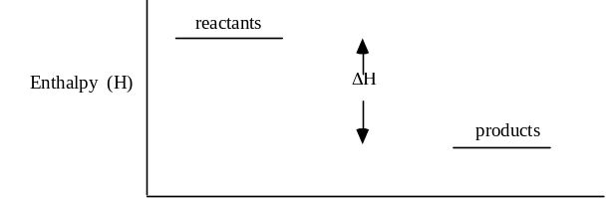

5. After an exothermic reaction, the products contain ............. stored potential energy (enthalpy) than that contained in the original reactants. But energy cannot be destroyed, instead, in an exothermic reaction, it is converted to ………… energy.

6. This heat energy that is given out, by the system, during an exothermic reaction, ................................ the temperature of the surroundings.

7. The difference between the enthalpies of the products and the reactants is called the change in enthalpy or the heat of the reaction, and it is given the symbol of ΔH.
For an exothermic reaction, the heat released is equal to the enthalpy difference between the products and the reactants i.e. ΔH. Thus, ΔH for an exothermic reaction always has a ......................... sign. (H _{product} - H _{reactant})

8. For example, the reaction of hydrogen with oxygen (the "pop" test), can be
represented by the following equation
2H₂(g) + O₂(g) → 2H₂O(g) ΔH = -484 kJ.
This means that when 2 moles of hydrogen react with 1 mole of oxygen
........... kJ of heat is ................................ to the surroundings.

A-1 system,
surroundings

A-2 enthalpy (heat content or potential energy)

A-3 enthalpy (potential energy)

A-4 greater

A-5 less,
heat

A-6 increases

A-7 negative

9. The equation 2H₂(g) + O₂(g) → 2H₂O(g) ΔH = -484 kJ also shows that the enthalpy (potential energy) of the ......................... is 484 kJ less than the
enthalpy (potential energy) of the .............................
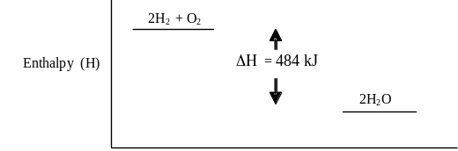

10. The enthalpy change for a reaction is sometimes included in the equation.
An exothermic reaction can be represented as: reactants → products + energy.
The reaction of hydrogen with oxygen could therefore be represented as:
...................... + .......................... → ...................... + 484 kJ

11. When 2 moles of gaseous HCl are decomposed to form 1 mole of hydrogen gas and 1 mole of chlorine gas, 412 kJ of heat are evolved. The equation for this reaction, showing heat included in the equation is
...................................................... → ........................................................

12. Using data from Q 11, it can be concluded that the potential energy (enthalpy) of 2 moles of HCl is ........................................... than the potential energy of
(1 mole of H₂ + 1 mole of Cl₂).

13. When HCl decomposes to form H₂ and Cl₂ will the temperature of the surroundings will ....................................

14. ΔH for the reaction 2HCl → H₂ + Cl₂ is ............................

15. The enthalpy (potential energy) diagram for the decomposition of HCl referred to in Q 11, could be represented in the following way:

Enthalpy
(kJ)
2HCl
100
200
300
400
Reaction co-ordinate

16. When ammonium nitrate is dissolved in water, the temperature of the water decreases. A reaction which causes a decrease in the temperature of the surroundings is called an ............................... reaction.

17. In an endothermic reaction, the enthalpy (stored potential energy) of the reactants
is .......................... than the enthalpy (stored potential energy) of the products:
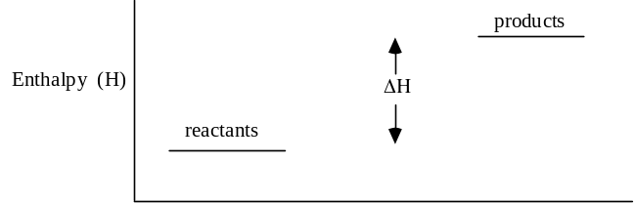
A-8 484, released (given out)

A-9 products,
reactants

A-10
2H₂(g) + O₂(g) →
2H₂O(g) + 484 kJ

A-11

2HCl → H₂ + Cl₂ + 412 kJ

A-12 greater

A-13 increase

A-14 -412 kJ

A-15
H₂ + Cl₂
2HCl
200
400

A-16 endothermic

18. When an endothermic reaction occurs, some of the heat energy from the surroundings is changed into potential energy. This potential energy is stored in the products. Consequently, the products contain .................... stored potential energy than the reactants. Also, because the surroundings have lost some heat energy, the temperature of the surroundings ......................... during the reaction.

19. For an endothermic reaction, the heat absorbed by the system is equal to the enthalpy difference between the products and the reactants i.e. ΔH = H _{product} - H _{reactant} . Therefore, ΔH, for endothermic reactions will always have a .......................... sign

20. The heating of liquid water to form gaseous water (steam) can be represented by the equation
H₂O(l) → H₂O(g) ΔH = +44 kJ.
This means that when 1 mole of liquid water is converted to 1 mole of steam, 44 kJ of heat energy is absorbed from the surroundings and converted to 44 kJ of stored potential energy in the ...........................
That is, the product contains ............ kJ more potential energy than the reactant.

21. This equation for the boiling of water could also be written showing the heat absorbed as part of the equation i.e. ...................................................... → .................

22. The reaction between hydrogen and iodine to form hydrogen iodide can be represented by the equation
H₂(g) + I₂(g) + 52 kJ → 2HI(g).
This reaction is ............................. and the temperature of the surroundings would ........................ during the reaction.

Revision

23. When ammonium nitrate is dissolved in water, the solution becomes cold.

This process is said to be an ...................................... reaction because the temperature of the surroundings has ....................................... The graph indicating the relative enthalpies of the reactant and products and the change in enthalpy that occurs during the process can be drawn as

enthalpy

24. The reaction between sulfur and oxygen can be represented by the equation
S(s) + O₂(g) → SO₂(g) + 297 kJ

This process is said to be an ...................................... reaction because heat is ………………. to the surroundings and the temperature of the surroundings ………………. The graph indicating the relative enthalpies of the reactant and products and the change in enthalpy that occurs during the process can be drawn as

enthalpy

A-17 less

A-18 more,
decreases

A-19 positive

A-20 steam (product)
44 kJ

A-21
H₂O(l) + 44 kJ → H₂O(g)

A-22 endothermic,
decrease

A-23 endothermic
decreased
product
H
ΔH
reactant

Bond breaking and formation processes

25. Energy is required to break bonds between particles making up a substance. That is, the separated particles have ................ stored potential energy (or enthalpy) than the 'joined' particles.

26. When bonds are formed between particles, energy is ...................

27. The energy required to break bonds is a measure of the strength of the bonds. ........................energy is required to break stronger bonds than weaker bonds.

28. The amount of energy released when bonds form is also a measure of the strength of the bonds. ................... energy is released when weak bonds form compared to when strong bonds form.

29. Many chemical reactions can be regarded as a 'two step process'. The first step involves the breaking of bonds i.e. a process requiring e......................., followed by a second step which involves the forming of new bonds i.e. an energy r......................... step.

30. If in a reaction, the bonds to be broken are stronger than the new bonds being formed i.e. ............ energy must be supplied to break the bonds, compared to the energy released in forming the new bonds, the reaction will be endothermic.

31. For example, in the diagram drawn below for the reaction 2H₂O → 2H₂ + O₂
step 1. is the bond-............................... step and step 2. is the bond-........................... step. For this reaction ΔH would have a ...................... sign
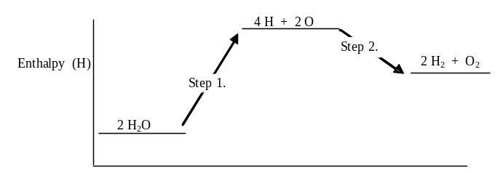

32. For an exothermic reaction, like the example given in the diagram below,
Reaction: 2H₂ + O₂ → 2H₂O
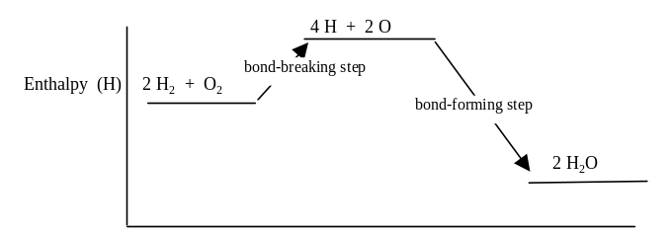

the bonds to be broken are ....................... than the new bonds being formed i.e. ................... energy must be supplied to break the bonds, compared to the energy released in forming the new bonds.

A-24 exothermic
released
increases
reactant
H
ΔH
product

A-25 more

A-26 released (given out)

A-27 More

A-28 Less

A-29 energy
releasing

A-30 more

A-31 breaking
forming
positive

Examples of exothermic and endothermic reactions

33. Burning (or c..........................) reactions involve the reaction of substances with .................................. For example, when methane (natural gas) undergoes combustion, the following reaction takes place:
CH₄ + 2 .......... → CO₂ + 2H₂O
Combustion reactions are e............................................ reactions.

34. Changes in state from gas to liquid (c......................................) and liquid to solid (s.....................................) are ......................................... reactions. That is, potential energy in the system is converted to .............. energy which is .................... to the surroundings.

35. Reactions which involve the formation of bonds are e......................................... That
is, when two particles bond together, ....................... energy is produced.
For example,
- reactions in which single atoms b............... together e.g. 2Cl(g) → Cl₂(g)
- reactions in which an electron is gained by a p..................... ion
e.g. Na⁺(g) + e → Na(g)
are exothermic reactions.

36. Respiration, the process which is carried out by all living things, is also an e......................................... reaction. The energy p........................... in the reaction is essential for life.
In this process, glucose reacts with oxygen according to the equation:
C₆H₁₂O₆ + 6O₂ → 6................ + 6................

37. Reactions in which molecules are "broken up" to form single atoms
e.g. Cl₂(g) → 2Cl (g) are e.................................... reactions. That is, heat energy is ......................................... the surroundings and converted into potential energy
which is stored in the separated atoms. Consequently, the separated atoms have a ........................... potential energy (enthalpy) than the original molecules.

38. Reactions in which an atom or ion loses an electron e.g. Na (g) → Na⁺(g) + e
are e.....................................

39. Changes in state from solid to liquid (m.......................), liquid to gas
(v.......................) and solid to gas (s..............................) are e............................. .

40. For example, when a solid melts, heat energy from the surroundings is converted to .................................. energy which is contained in the l......................... particles. That is, the liquid particles have a .............................. potential energy than the solid particles. (Also, the distance between the liquid particles is ................................. than the distance between the solid particles.)

41. Photosynthesis, the process in which plants produce glucose, is also an e....................................... reaction.
In this process, carbon dioxide and water, in the presence of s............................ and c......................................, are converted to glucose and oxygen, according to the equation
6............... + 6................ → C₆H₁₂O₆ + 6................

A-32 weaker
less

A-33 combustion
O₂
exothermic

A-34 condensation
solidification
exothermic
heat
given out

A-35 exothermic
heat
bond
positive

A-36 exothermic
produced
CO₂ H₂O

A-37 endothermic
taken in (absorbed from)
larger

A-38 endothermic

A-39 melting
vaporisation
sublimation
endothermic

A-40 potential
liquid
larger
larger

A-41 endothermic
sunlight chlorophyll
6CO₂ + 6H₂O → C₆H₁₂O₆ + 6O₂

